Second WORKSHOP for Capacity Building of Women in Statistics and Data Science supported by International Statistical Institute | 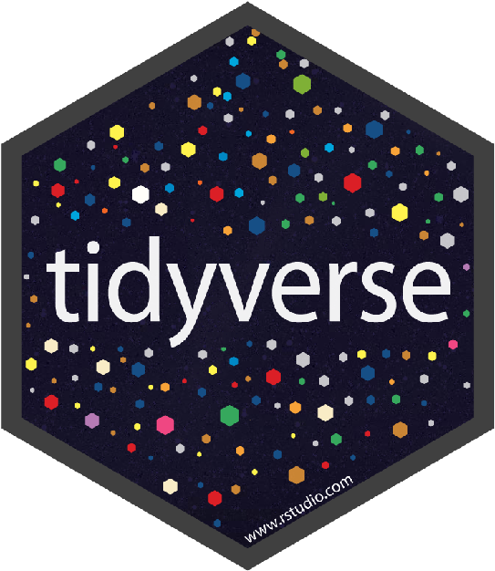
Workshop title: “Tidyverse for Data Science”
Organized by: LISA-LCWU Department of Statistics, LCWU, Lahore
Kindly provide the information below for registration.

Name:
Age: Department:

Class/Qualification: Semester:

Whatsapp. No./Cell No.
What software you already have hands on skills for Statistical computing?
STATA SPSS E-View R Language Tidyverse Mathematica
Any Other: _________________

Rate your knowledge about R-language | Very Satisfied | Satisfied | Not Sure | Unsatisfied | Very Unsatisfied
I want to become professional data analyst | Strongly Agree | Agree | Not Sure | Disagree | Strongly Disagree
Special Instructions for joining online course:
As per requirement of the course you must have laptop or computer system (with 64bit operating system) with R and RStudio Installed on it. For your convenience following links are given. Here first you need to install R and then R studio.
R: https://www.dropbox.com/s/amnjz2g5snq5p7d/R-3.6.0-win.exe?dl=0
RStudio: https://www.dropbox.com/s/oyxst2oe0tajmf9/RStudio-1.2.1335.exe?dl=0

Submit at:lisalcwu@gmail.com
Venue: Statistics Department Lab (LAB 01), Social Science Building PG 2
Note: Due to limited seats, preference will be given to first come first serve basis.
LISA-LCWU
Laboratory for Interdisciplinary Statistical Analysis LCWU

