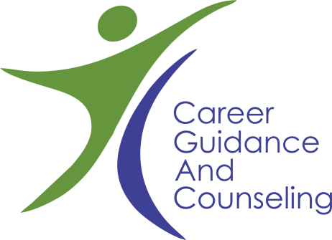
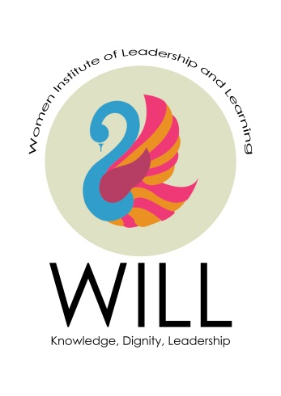
A brief Guide to Well Being: tips to take care of physical and mental health
By: Mamoona Riaz
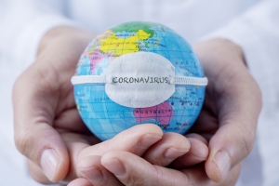
Along with good hygiene and balanced diet, follow these tips to help yourself and loved ones around you to express thinking, feeling, and communicate appropriately.
Looking for heroes: in every disaster and hard time there are people who act with marked bravery and come at forefront for good of others. Think and look around for those like medical professionals, bankers, or simply the ones who isolate themselves to protect all around. This mindfulness will create moral elevation, positive emotions and desire to act altruistically.
Be Humane and show compassion: in the amid of adversity and bad news all around try to support and help the ones in need. The state only cannot meet the crisis we as nation can solve this big problem together. Show some generosity and care around.
Stay calm and focused: don’t be panic and chaotic. Being mindful to blessings, taking to friend or getting involved in art and craft can help in calming down.

For more help and information contact us at:
Career Guidance and Counseling Centre
Besides Exam Branch PG II, LCWU
+92 99203801 ext 258
email at: cgcc.lcwu@gmail.com or
find us on Facebook at
https://www.facebook.com/Career-Guidance-Counseling-Centre-LCWU-180640212442965

